LOGICAL MODEL:

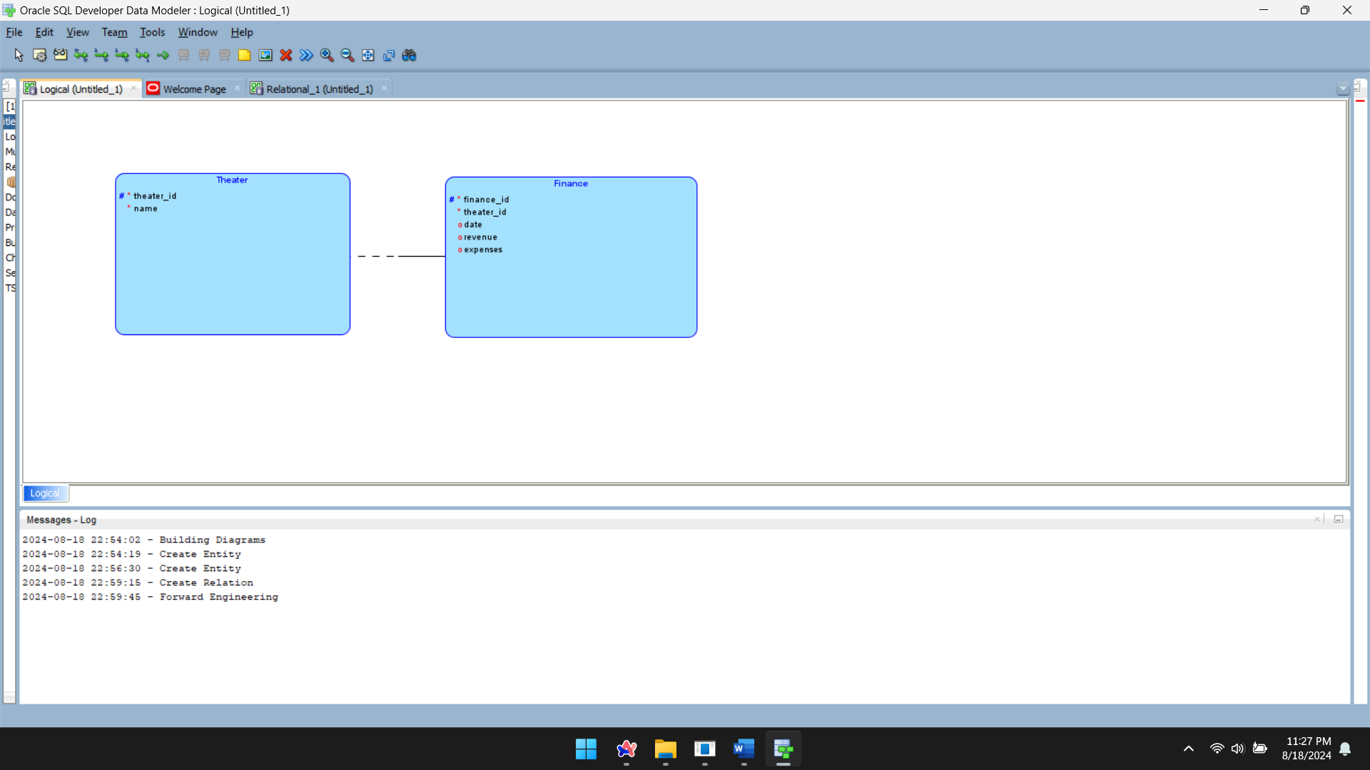

PHYSICAL MODEL:

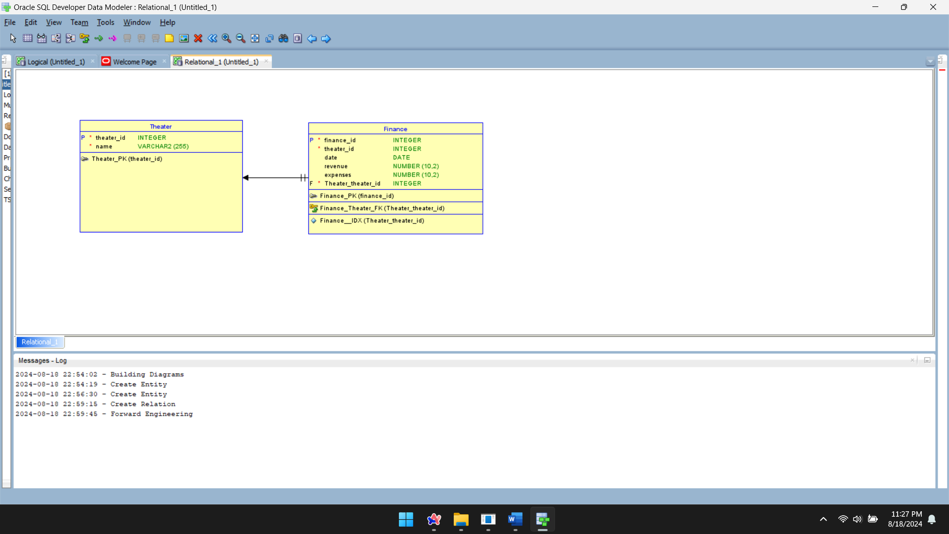

CREATE TABLE Theater (

theater_id INT PRIMARY KEY,

name VARCHAR(255) NOT NULL

);

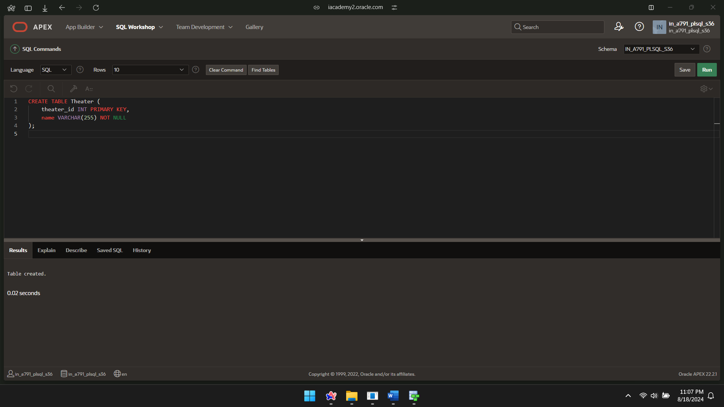

CREATE TABLE Finance(

financial_id INT PRIMARY KEY,

theater_id INT,

dates DATE,

revenue DECIMAL(10, 2),

expenses DECIMAL(10, 2),

FOREIGN KEY (theater_id) REFERENCES Theater(theater_id)

);

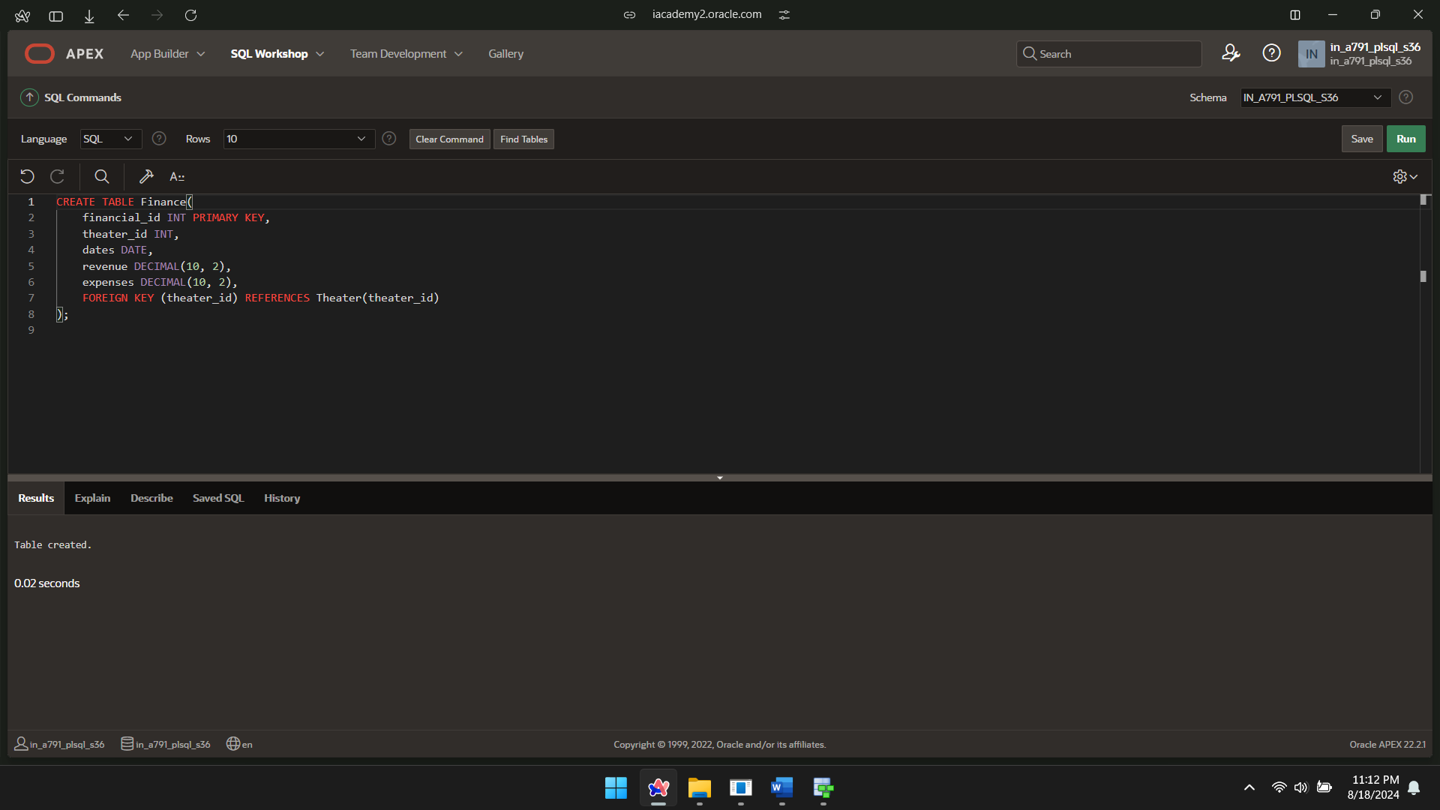

INSERT INTO Theater (theater_id, name) VALUES (1, 'Theater 1');

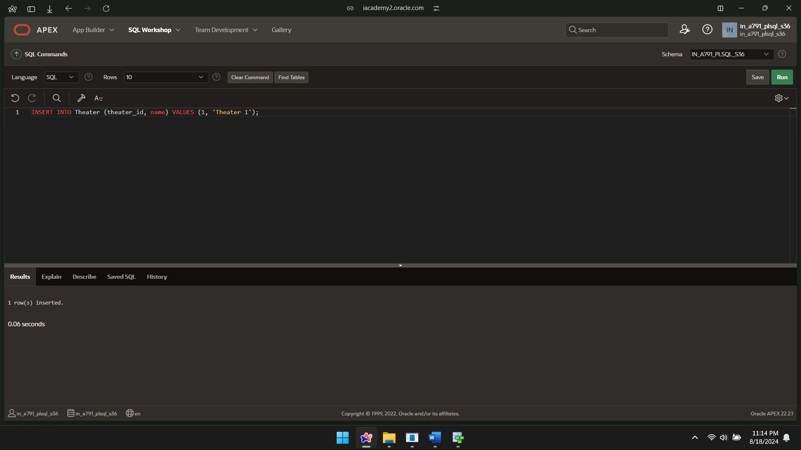

INSERT INTO Theater (theater_id, name) VALUES (2, 'Theater 2');

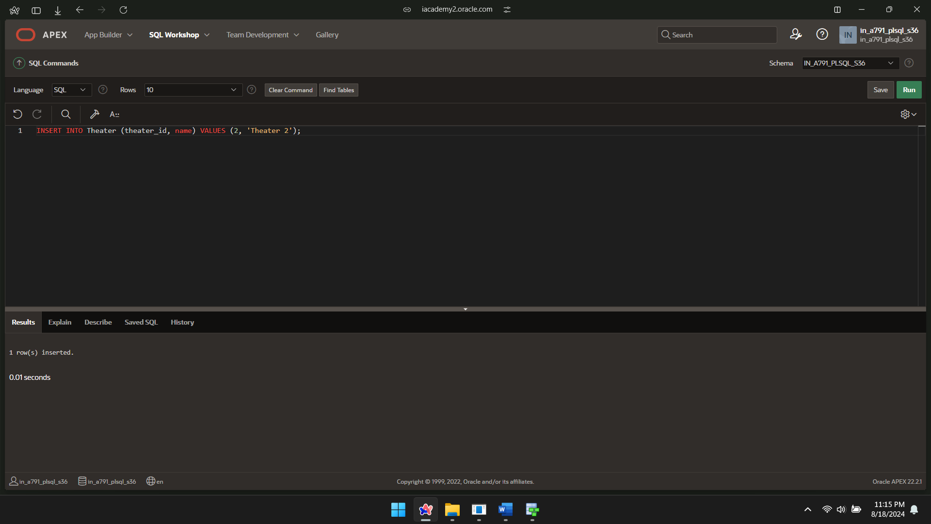

INSERT INTO Theater (theater_id, name) VALUES (3, 'Theater 3');

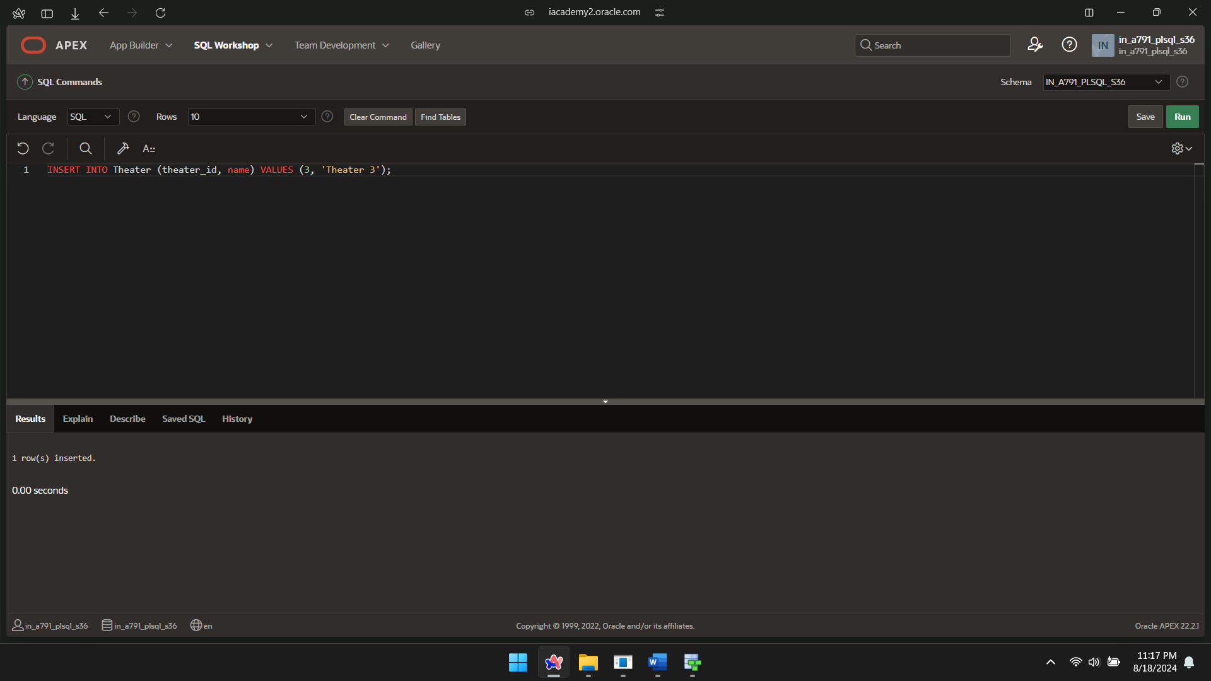

INSERT INTO Finance(financial_id, theater_id, dates, revenue, expenses)

VALUES (1, 1, DATE'2024-08-15', 9000.00, 2000.00);

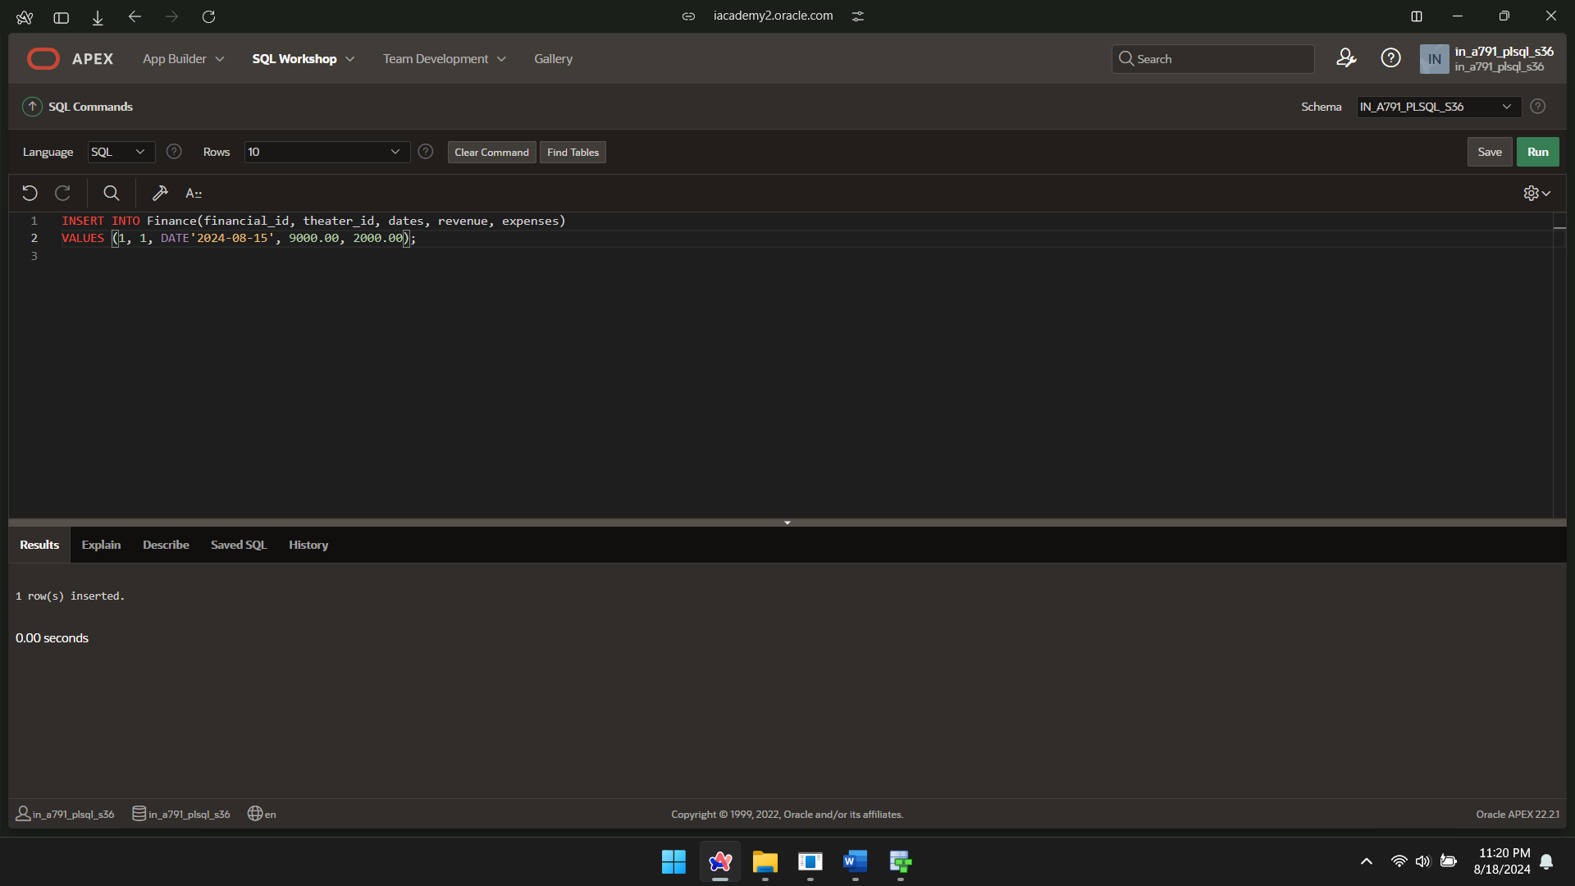

INSERT INTO Finance(financial_id, theater_id, dates, revenue, expenses)

VALUES (2, 2, DATE'2024-08-15', 8700.00, 4000.00);

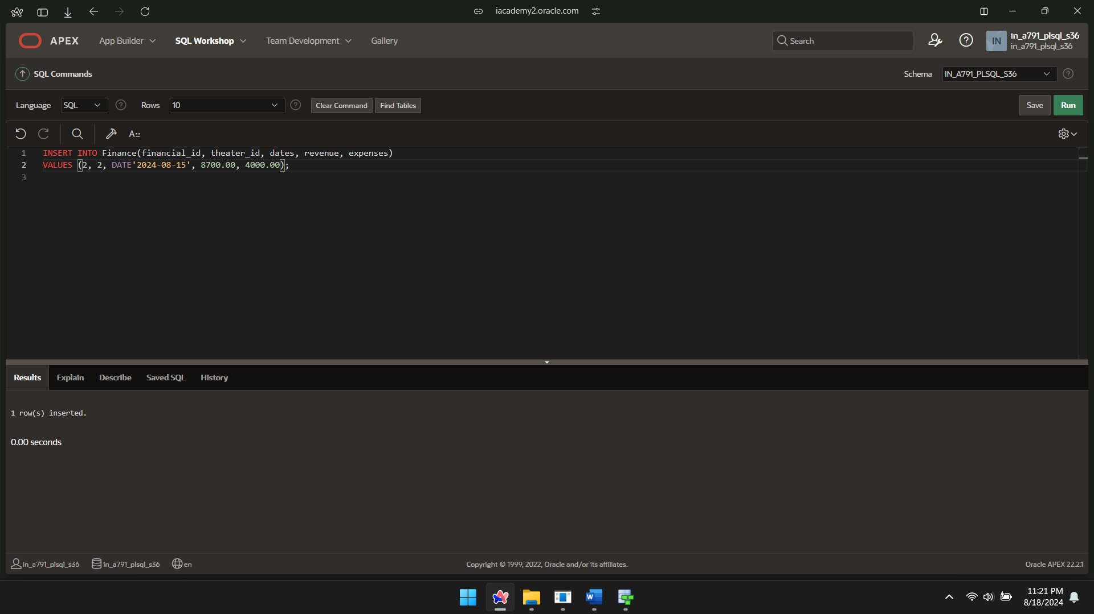

INSERT INTO Finance(financial_id, theater_id, dates, revenue, expenses)

VALUES (3, 3, DATE'2024-08-15', 6500.00, 3900.00);

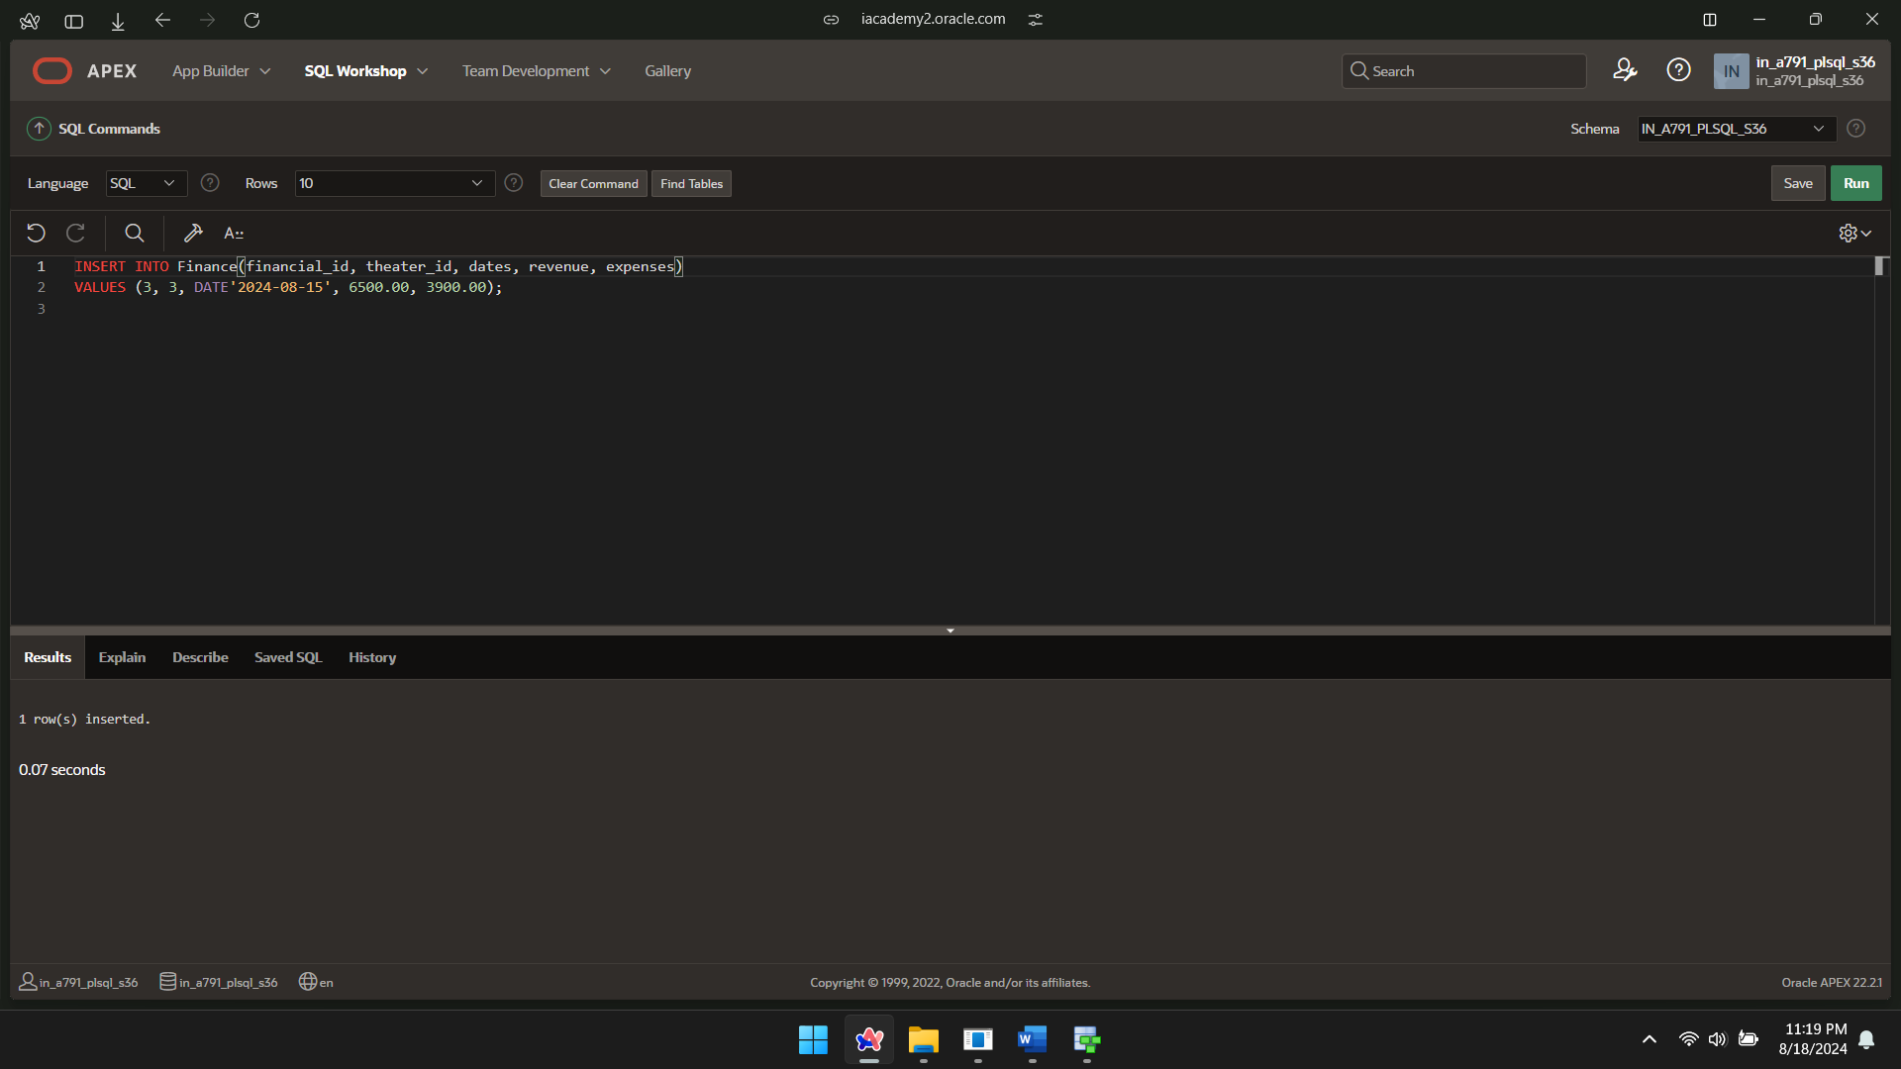

DECLARE

CURSOR financials_cur IS

SELECT

dates,

SUM(revenue) AS total_revenue,

SUM(expenses) AS total_expenses,

SUM(revenue) - SUM(expenses) AS total_profit

FROM

Finance

WHERE

dates BETWEEN TO_DATE('2024-08-15', 'YYYY-MM-DD') AND TO_DATE('2024-08-16', 'YYYY-MM-DD')

GROUP BY

dates

ORDER BY

dates;

BEGIN

FOR rec IN financials_cur LOOP

DBMS_OUTPUT.PUT_LINE('Date: ' || rec.dates || ', Total Revenue: ' || rec.total_revenue ||', Total Expenses: ' || rec.total_expenses || ', Total Profit: ' || rec.total_profit);

END LOOP;

END;

/

